**INTERACTION DIAGRAMS-SEQUENCE AND COLLABORATION DIAGRAM**

**AIM:**

To design the UML sequence and collaboration diagram for the Online Exam Registration System.

**DEFINITION:**

A sequence diagram is an interaction diagram that shows how objects operate with one another and in what order. It is a construct of a message sequence chart.A sequence diagram shows object interactions arranged in time sequence. Sequence diagrams are sometimes called event diagrams or event scenarios.

A Collaboration diagram models the interactions between objects or parts in terms of sequenced messages. The diagrams represent a combination of information taken from Class, Sequence, and Use Case Diagrams describing both the static structure and dynamic behavior of a system.

**SEQUENCE DIAGRAM:**

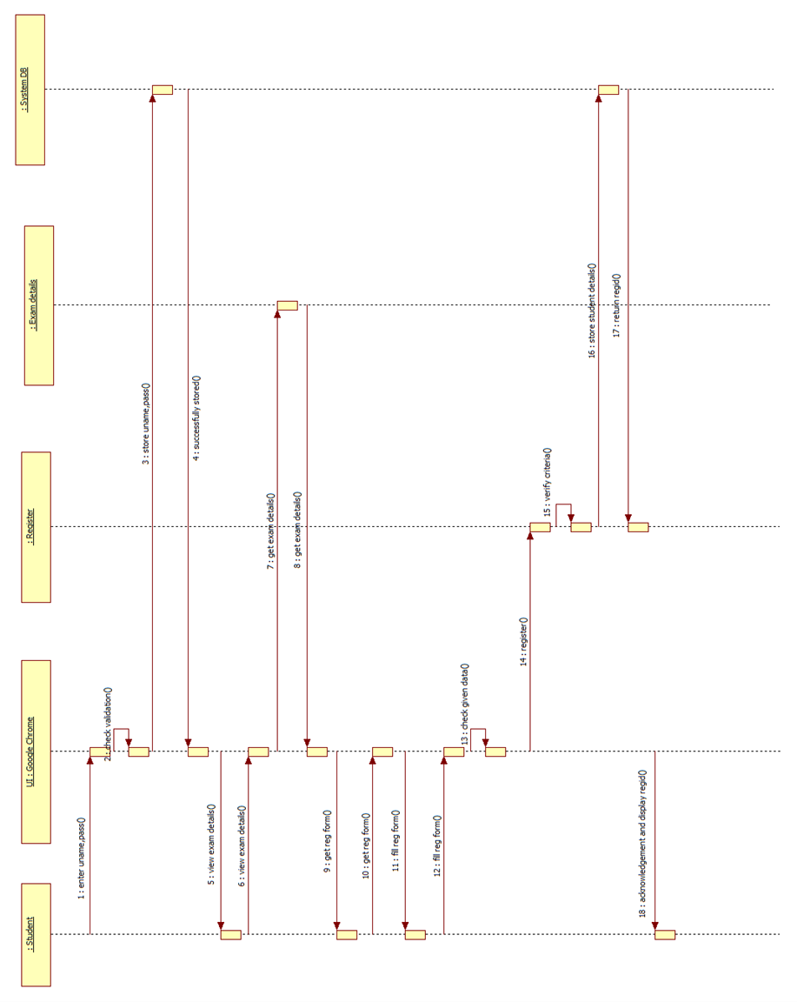

**SEQUENCE OF OPERATIONS:**

The username and password are entered and the login credentials are verified. Once logged in, the available exams and their details are displayed. The student selects a particular exam and fills in his details in a registration form. The details are checked by the administrator and the registration process for the particular student and his exam selection is initiated. Now the administrator verifies if the student meets the exam’s criteria and if he does an acknowledgement is displayed with his registration ID. If not, an error is displayed and the student is asked to exit.

**COLLABORATION DIAGRAM:**

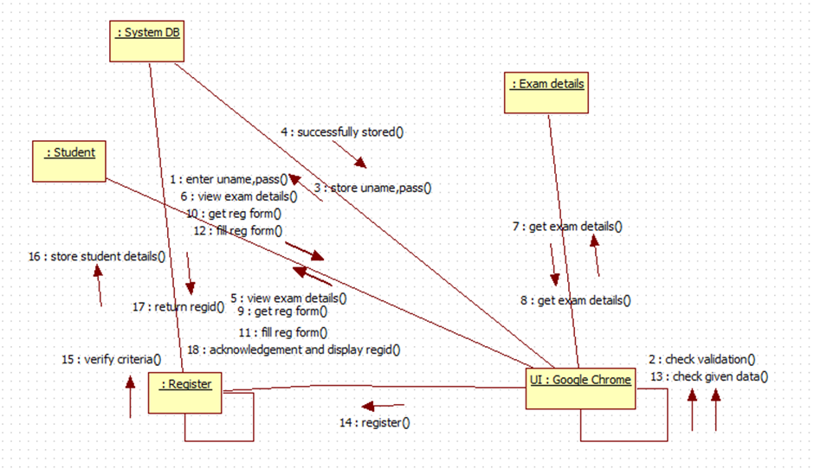

**RESULT:**

Thus the sequence and the collaboration diagram for the Online Registration System has been designed and verified.